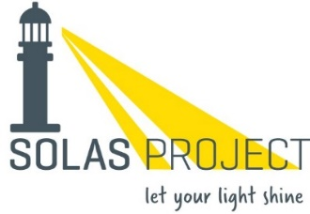

Complaints Form

Please complete all sections of this form using block letters.

Name of person making complaint: …………………………………………………………

Address (adults only) …………………………………………………………………………

…………………………………………………………………………………………………….

I am a (circle one)
Parent/Guardian Young Person Volunteer Other (specify)………………
Phone number (adults only) …………………………………

Date & time complaint was first made: …………………………….

Date & time of incident: …………………………….

Name of person to whom complaint was first made: ……………..………………………………………..

Details of Complaint:

….…………………………………………………………………………………………………...

………………………………………………………………………………………………………

………………………………………………………………………………………………………

………………………………………………………………………………………………………

………………………………………………………………………………………………………

(Please continue on an additional sheet if required)

Signature: ……………………………………… Date: ……………………..……

Please return to:
Team Leader or Amy Carey, Solas Project, Unit 1 Liberty View, Longs Place, Dublin 8

Received and read by (Team Leader or Programme Manager)

Signature: ………………………………………………. Date: ……………………….

